TOEIC LISTENING TRANSCRIPT
Practice Test 3 — Full Audio Script (Part 1, Part 2 & Part 3)

PART 1: PHOTOGRAPHS (Questions 1 – 6)
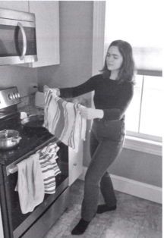
Number 1
(A) She’s cleaning an oven.
(B) She’s moving a pot.
(C) She’s opening a cabinet.
(D) She’s holding a towel.
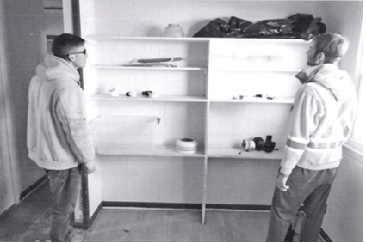
Number 2
(A) They’re putting trash in a bag.
(B) They’re taking off their jackets.
(C) They’re facing a shelving unit.
(D) They’re painting a room.
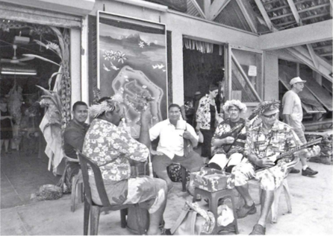
Number 3
(A) One of the men is removing his hat.
(B) A line of customers extends out a door.
(C) Some workers are installing a sign.
(D) Musicians have gathered in a circle.
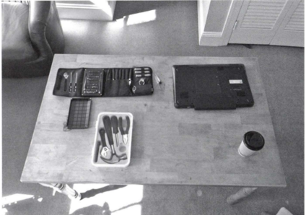
Number 4
(A) Some tools have been left on a chair.
(B) Some tool sets have been laid out.
(C) A cup of coffee has spilled.
(D) A table leg is being repaired.
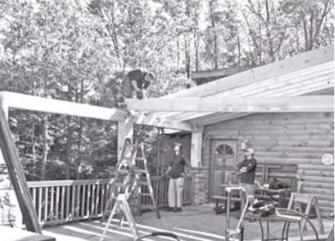
Number 5
(A) A railing is being removed.
(B) A roof is under construction.
(C) Some workers are carrying a ladder.
(D) Some workers are holding sheets of metal.
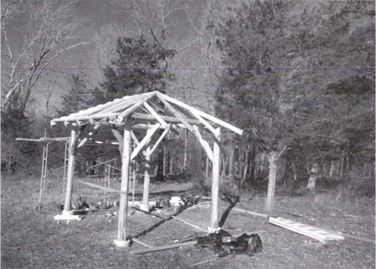
Number 6
(A) A ladder has been leaned against a tree.
(B) There are piles of tree branches discarded in a field.
(C) Wooden benches have been arranged in a circle.
(D) A wooden structure has been built near some trees.
PART 2: QUESTION-RESPONSE (Questions 7 – 31)
Number 7: Why is there no flour on the shelf?
(A) Because it’s out of stock.
(B) Those roses smell nice.
(C) No, the other cake.
Number 8: When will the catering company arrive?
(A) At 4 o’clock.
(B) That’s a delicious flavor.
(C) Many vegetarian options.
Number 9: When’s the meeting scheduled to start?
(A) At a networking event.
(B) I started this job six years ago.
(C) Right after lunch.
Number 10: How much will the repairs cost?
(A) I have two pairs of shoes.
(B) Around $200.
(C) The restaurant downtown.
Number 11: You went to the dentist this morning, didn’t you?
(A) Oh, I’ve already had breakfast.
(B) Yes, for an annual checkup.
(C) Let’s take the bus.
Number 12: Where should we put the new printer?
(A) In the corner by the stairs.
(B) The third page of the document.
(C) A reusable ink cartridge.
Number 13: What type of plant do you have in your office?
(A) Whenever I sit at my desk.
(B) Thanks, I just bought it.
(C) One that doesn’t require much water.
Number 14: There was a sale at the furniture store.
(A) No, it wasn’t in storage.
(B) Did you buy anything?
(C) Some old receipts.
Number 15: Can you show me how to submit a tech help ticket?
(A) Let me send you the link.
(B) A broken power cable.
(C) No, over 10 minutes.
Number 16: Where is the power button on this device?
(A) I’ve never used that model before.
(B) 10 euros per hour.
(C) We charge more for color photographs.
Number 17: Do you want to take a walk now, or would later be better?
(A) A nearby lake.
(B) I’m free to walk now.
(C) No, I don’t use a fitness tracker.
Number 18: I ordered some new equipment for the factory.
(A) The news program on channel 10.
(B) Great, I can’t wait to use it.
(C) The car dealership.
Number 19: There’s a nice place to rent on Mercer Street.
(A) I just renewed my current lease.
(B) It was a great show.
(C) A standard rental application.
Number 20: Is the heating system working?
(A) Yes, that’s my website.
(B) A 5-kilometer run.
(C) I just called maintenance.
Number 21: Isn’t the roadwork in front of City Hall finished yet?
(A) I just finished my conference presentation.
(B) A lot of traffic in the evening.
(C) No, they still have another month to go.
Number 22: Who will lead the new employee training today?
(A) We’re using a recorded video.
(B) Yes, right after lunch.
(C) Classroom 124.
Number 23: Is the safety inspection scheduled for this month or next month?
(A) I thought I saved the file.
(B) The factory supervisor.
(C) It’s this Wednesday.
Number 24: When is the harvest festival taking place?
(A) It’s a week from tomorrow.
(B) Sure, I can take it.
(C) The park next to the art museum.
Number 25: Was your new laptop expensive?
(A) Do you have a new password?
(B) I had a discount coupon.
(C) On top of the cabinet.
Number 26: Why don’t we go on our camping trip next weekend?
(A) Yes, that table lamp is quite nice.
(B) Should we go left or right?
(C) I have a performance scheduled with my band.
Number 27: The workshop for this afternoon was postponed, wasn’t it?
(A) At the post office.
(B) I haven’t checked my email.
(C) A ticket for 2 o’clock, please.
Number 28: How were our production figures last month?
(A) They produce electric cars.
(B) 9 o’clock in the morning.
(C) We were closed down for a week.
Number 29: When can I see the speech therapist?
(A) A one-hour session.
(B) Just a microphone.
(C) How about tomorrow afternoon?
Number 30: Aren’t you picking up the clients from the airport?
(A) A product demonstration.
(B) No, I believe Tomiko is doing that.
(C) He prefers an aisle seat.
Number 31: How was your morning client meeting?
(A) It’s great to meet you.
(B) No, over in conference room 2.
(C) The contract is now officially signed.

PART 3: SHORT CONVERSATIONS (Questions 32 – 70)
Questions 32–34
Man: The company’s making a big change this year by moving offices. It’s exciting that the new space will be much bigger.
Woman: Yes. Do you know what the company’s planning to do with our meeting tables and chairs?
Man: Well, the new location already has furniture, so we don’t need them.
Woman: Why don’t we donate them? The Jebbrian Foundation is a local organization that picks up old furniture for donation.
Man: That’s a good idea. Let’s talk to our directors to see what they think.
Question 32: What change is a company making?
(A) It is lowering some prices. (B) It is hiring more staffers. (C) It is moving to a new location. (D) It is expanding a product line.
Question 33: What suggestion does the woman make?
(A) Updating a handbook (B) Donating some furniture (C) Creating a schedule (D) Downloading a software program
Question 34: What will the speakers most likely do next?
(A) Train a new employee (B) Review an application (C) Check a list (D) Talk to some directors
Questions 35–37
Man: Welcome. I’m excited to show you both around the Southeast Medical Trade Show.
Woman 1: Thanks for allowing us to cover the event for our newspaper. We really wanted to interview you as the organizer.
Woman 2: Yes. How many people are you expecting to attend this trade show?
Man: I’m pleased to report that registration has increased this year. We have over 2,000 participants.
Woman 2: That’s impressive.
Man: It’s our best turnout yet.
Woman 1: Actually, before we go into the main room, can we get a photo of you in front of the poster for the show—the one on that wall?
Man: Certainly.
Question 35: Who most likely are the women?
(A) Company executives (B) Journalists (C) Health-care professionals (D) Safety inspectors
Question 36: What does the man say he is pleased about?
(A) The number of event participants (B) The amount of money raised (C) The quality of vendors (D) The variety of presentations
Question 37: What will the women do next?
(A) Watch a demonstration (B) Get some refreshments (C) Register for an event (D) Take a photograph
Questions 38–40
Woman: Murat, I need your help. Can you spare 30 minutes?
Man: I have some time after lunch. How can I help?
Woman: As you know, I’ve been redesigning Ace Bancorp’s website to add new online banking functions.
Man: This is the client that wanted streamlined menus on their home page too, right?
Woman: Yes. I wonder whether you could test out the redeveloped site for me.
Man: I can do that. Why don’t you send me a list of the specific updates you made? I’ll make sure I check those.
Question 38: What most likely is the woman’s job?
(A) Professional chef (B) Bank executive (C) Administrative assistant (D) Web designer
Question 39: What will the man most likely do?
(A) Buy some materials from the woman (B) Check the woman’s work (C) List investment options (D) Update some client information
Question 40: What will the woman most likely send to the man?
(A) A cost estimate (B) A revised schedule (C) A building plan (D) A list of changes
Questions 41–43
Man: Excuse me, I’m trying to catch a train from this platform, but I’ve been waiting, and no train has arrived.
Woman: Oh, yes. Unfortunately, some tracks are being repaired, so no trains are departing from this platform.
Man: I see. I had no idea this was happening, and I’m upset that now I’m late for an appointment.
Woman: Well, they’re providing free bus service to the next few stations. You can catch a shuttle bus from the south side of the station.
Question 41: Why is a train platform closed?
(A) Safety inspections are being conducted. (B) New escalators are being installed. (C) Tracks are being repaired. (D) Waiting areas are being remodeled.
Question 42: What does the man say he is upset about?
(A) Misunderstanding some instructions (B) Being late for an appointment (C) Losing a travel pass (D) Boarding the wrong train
Question 43: What will the man most likely do next?
(A) Purchase a snack (B) Take a shuttle bus (C) File a complaint (D) Download a map
Questions 44–46
Man: Thanks for taking my call, Ms. Hazarika.
Woman: I understand from your email that you’re looking for investors in your business.
Man: Yes. Storing bikes in small apartments is tough. That’s why I’ve developed this space-saving bicycle rack.
Woman: I’ve seen other indoor bike racks. What’s unique about yours?
Man: Most indoor racks are one size, but not all bikes are the same. My product can be adjusted to suit different types of bicycles.
Woman: That’s interesting. Send me your business model. I need to determine if you have a reasonable plan for expanding production and increasing sales before I make any decisions.
Question 44: Why does the man call the woman?
(A) To provide an update on his project (B) To get approval on some design changes (C) To receive the woman’s feedback on a prototype (D) To persuade the woman to invest in his business
Question 45: According to the man, what is unique about a product?
(A) It is inexpensive. (B) It is easy to assemble. (C) It is adjustable. (D) It is lightweight.
Question 46: Why does the woman request some documents?
(A) To open a customer account (B) To issue a certificate (C) To make some copies (D) To evaluate a proposal
Questions 47–49
Woman: Alberto, it’s time to leave the studio and head over to the Central Bank for our interview with the director.
Man: Yes, I have all the cameras we’ll need today.
Woman: Great. And make sure you have the special low-light lenses. I’m concerned about the poor lighting at the bank. It’s pretty dark in there, and that can ruin our key interview shots.
Man: Oh, yes, I have those. And by the way, our new intern Marcel Lambert is interested in joining us.
Woman: That’s a good idea. It’ll be a good experience for him.
Question 47: What are the speakers preparing for?
(A) A construction-site visit (B) A safety inspection (C) An interview (D) A film festival
Question 48: What is the woman concerned about?
(A) A lighting issue (B) A script mistake (C) A material shortage (D) A revenue decrease
Question 49: Who is Marcel Lambert?
(A) A company accountant (B) A possible client (C) A supervisor (D) An intern
Questions 50–52
Woman: Waseem, I know you’ve been very busy this morning, but did you have time to take care of the photocopies I asked for?
Man: Oh, yes. Those are all ready.
Woman: Excellent, thanks. By the way, how are the preparations coming along for Sabine Hoffmann’s retirement party?
Man: Great. I’ve booked a room and invited everyone on our team to the event. I’ll call the caterer next.
Woman: You know, I’m sure she would love to celebrate with her former colleagues from other teams as well, if it’s not too much trouble to invite them.
Man: Sure. I’ve booked conference room B, but I’ll go ahead and change that.
Question 50: What does the woman thank the man for?
Question 51: Why is a gathering being planned?
Question 52: What does the man imply when he says, "I’ve booked conference room B"?
Questions 53–55
Man: Hi, I’m Kota Ogawa from Langston Limited. I have an appointment with Ms. Ishikawa to view your hotel facilities for my company’s upcoming retreat.
Woman 1: I know that she’s been expecting you, and she just wrapped up an urgent phone call. She’s on her way now.
Woman 2 (Ms. Ishikawa): Hi, you must be Mr. Ogawa. I’m Hikaru Ishikawa. Why don’t we see our largest conference room first?
Man: Great. And I’d also like to look at the guest rooms. All the rooms have a high-speed Internet connection, right?
Woman 2 (Ms. Ishikawa): Yes. And we have a fully equipped recreation area as well.
Question 53: What type of event is the man planning?
Question 54: Why was Ms. Ishikawa delayed?
Question 55: What does the man inquire about?
Questions 56–58
Woman: Look at these results! Sales of pineapples have gone up a lot this month at our store.
Man: It must be the pineapple peeling machine we installed in the fruit aisle. Customers like watching it peel and slice their pineapple for them.
Woman: It is a unique experience. I think we should install one in our other two store branches.
Man: I’m not sure about that. I think the novelty will wear off in a few weeks. Let’s wait to see if sales numbers stay high before we invest in any more.
Question 56: Where does the conversation most likely take place?
Question 57: What does the man say is popular?
Question 58: What does the man suggest doing?
Questions 59–61
Man: Ingrid, we’ve had three patients this week who had to cancel their dental appointments at the last minute.
Woman: Yes, that’s a problem. Other patients might have taken those available appointments if we’d been able to contact them in time.
Man: You know, I have an idea. I recently scheduled a doctor’s visit online, and there was an option to receive a text message notification if an earlier slot became available. You just have to check a box. What do you think about something like that?
Woman: That would be helpful. I have some time this afternoon. I’ll look into software packages that include that feature.
Question 59: What are the speakers discussing?
Question 60: Why does the man say, "You just have to check a box"?
Question 61: What does the woman offer to do this afternoon?
Questions 62–64
Man: Hi Raquel, have you had a chance to look for something I could buy the employees for the New Year? I want to be sure I thank everyone for their hard work.
Woman: Well, a good quality travel mug would be appreciated.
Man: Interesting. Which one would you recommend?
Woman: Take a look at this brochure. This company has a variety of designs: sea animals, sky scenes... I like the medium mug with the Desert Roaming design.
Man: That is nice. I’ll sign off on that order request once you fill out the paperwork.
Question 62: Who will the man give some gifts to?
Question 63: Look at the graphic. How much is the mug that the woman likes?
Question 64: What does the man say he will do?
Questions 65–67
Man: Here’s the map that you requested for next week’s shoot, for the driving scene.
Woman: Great. Let’s see. The actors will be driving north on Maple Street. Hmm...
Man: Is something wrong?
Woman: We may need to alter the route so it’ll be less difficult for our camera operators to follow the action.
Man: Okay. What are you thinking?
Woman: Instead of turning left on Elm Lane, let’s have them turn right and park in front of the hair salon.
Man: Okay. I’ll arrange for that road to be closed while we’re working, and alert the business owners.
Question 65: What industry do the speakers most likely work in?
Question 66: Why does the woman want to make a change?
Question 67: Look at the graphic. Which road should be closed?
Questions 68–70
Woman: Hi Pablo, I wanted to talk to you about the video game we designed—the one we’re launching soon.
Man: Sure, did something come up?
Woman: Well, I think the Jungle level looks great, but in the Underwater level, there’s a problem with the part where the characters discover the lost city in the ocean. As I was going over the layout, I found a glitch in the gameplay.
Man: Oh, okay. We still have time to fix it.
Woman: Yes. But we should work on it as soon as possible. I could put some extra time in over the weekend. How about you?
Man: Probably. Just let me check my calendar.
Question 68: What are the speakers preparing for?
Question 69: Look at the graphic. Which level is the woman concerned about?
Question 70: What does the woman suggest doing?

